Hands On Exercises - JDBC

## **[Connection to database with Java](https://www.vogella.com/tutorials/MySQLJava/article.html" \l "jdbc)**

The interface for accessing relational databases from Java is *Java Database Connectivity (JDBC)*. Via JDBC you create a connection to the database, issue database queries and update as well as receive the results.

JDBC provides an interface which allows you to perform SQL operations independently of the instance of the used database. To use JDBC, you require the database specific implementation of the JDBC driver.

## **[MySQL JDBC driver](https://www.vogella.com/tutorials/MySQLJava/article.html" \l "jdbcdriver)**

To connect to MySQL from Java, you have to use the JDBC driver from MySQL. The MySQL JDBC driver is called *MySQL Connector/J*. The current folder **“Hands On Assignments”** conatins the jar file required.

## **[Exercise: create example database](https://www.vogella.com/tutorials/MySQLJava/article.html" \l "database)**

In this exercise you create a new database, a new user and an example table. For this connect to the MySQL server via the mysql command line client.

Create a new database called *feedback* and start using it with the following command.



Now create a sample database table with example content via the following SQL statement.

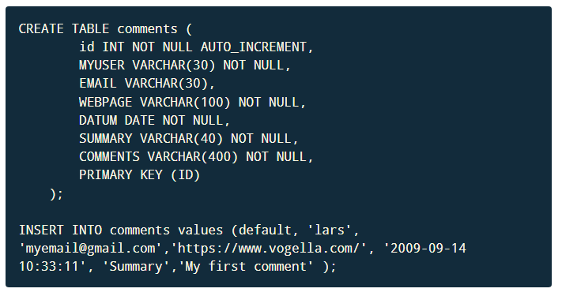



## **[Java JDBC](https://www.vogella.com/tutorials/MySQLJava/article.html" \l "javaconnection)**

Create a Java project called **JDBCFirstApp** and a package called *mysql.first*.

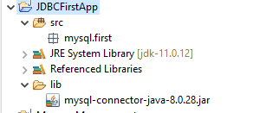

Create a lib folder and copy the JDBC driver into this folder. Add the JDBC driver to your classpath.

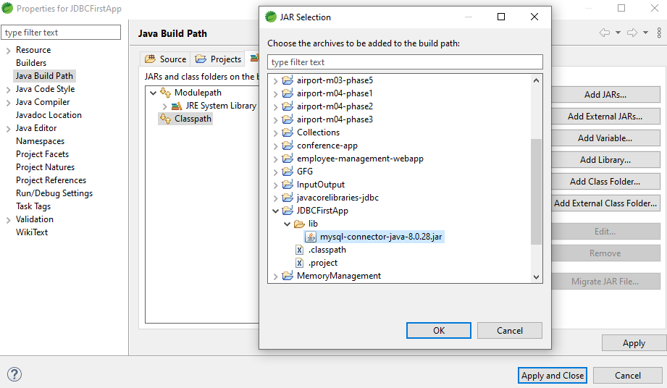

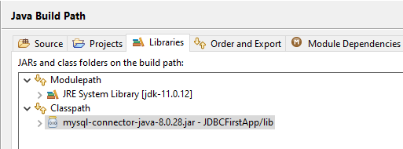

Create the following class to connect to the MySQL database and perform queries, inserts and deletes. It also prints the metadata (table name, column names) of a query result.

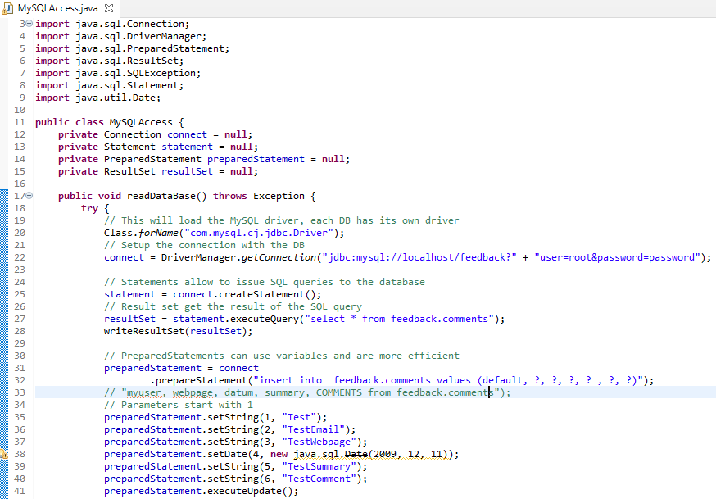

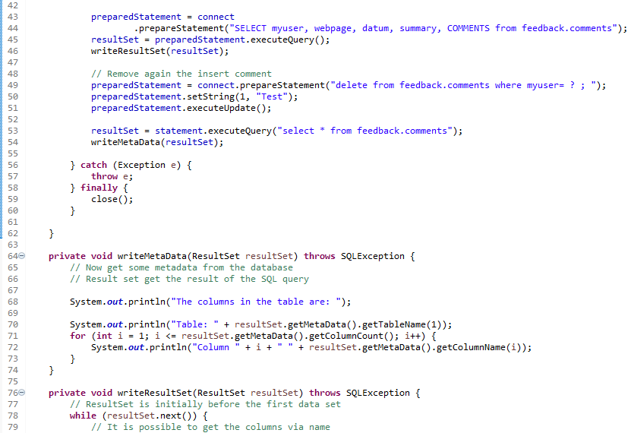

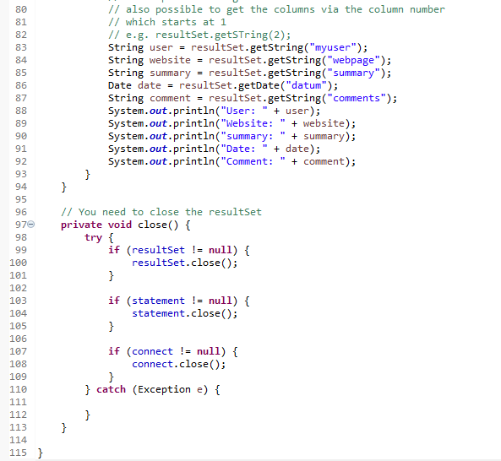

Create the following main program to test your class.



